Business Registration Process:
Ghana | The Gambia | Kenya
Nigeria | Rwanda | Tanzania | Uganda

Contributing Authors:
Heesoo Park, Jacob Stansell, Jennifer Byrne, Laura Clark, Miao Pan, Natalie Gallon,
Prianka Mohan, and Thinlay Chukki

Harvard Law and Development Society for New Markets Lab
August 2018

Table of Contents
Executive Summary 4
Business Registration in Ghana 6
Key Findings 6
Business Registration Process 6
Legal Framework 6
Registration Process 8
Summary of Registration Process 9
Business Registration in The Gambia 12
Key findings 12
Business Registration Process 12
Legal Framework 13
Registration Process 13
Environmental Assessment 14
Summary of Registration Process 15
Registering a Business in Kenya 17
Key Findings 17
Business Registration Process 17
Legal Framework 18
Online Portals 19
Sole-proprietor and Partnership Registration Process 20
LLP Registration Process 21
Company Registration Process 22
Summary of Regulatory Process 22
Business Registration in Nigeria 24
Key Findings 24
Business Registration Process 24
Legal Framework 25
Registration Process 26
Summary of Regulatory Process 28
Registering a Business in Tanzania 31
Key Findings 31
Business Registration Process 31
Registration Process 32
Summary of Regulatory Process 34
Business Registration Process in Rwanda 37
Key Findings 37
Business Registration Process 37
Sole-proprietorship Registration Process 38
Company Registration Process 38
Environmental Impact Assessment 39
Summary of Regulatory Process 41
Business Registration in Uganda 44
Key Findings 44
Business Registration Process 44
Legal Framework 44
Registration Process 45
Summary of Regulatory Process 52

Executive Summary
The following report was developed by the Harvard Law and International Development Society (LIDS) for the New Markets Lab (NML). NML has developed a signature regulatory mapping tool designed to visually depict and simplify processes and procedures contained in laws and regulations. NML’s regulatory maps cover trade measures, agricultural laws, and non-tariff measures, and NML is expanding its library of regulatory maps to complement its Legal Toolkit for small and medium-sized businesses (SMEs). To further build on NML’s regulatory maps, NML has launched in collaboration with LIDS, under the Trade Innovation Initiative jointly founded by LIDS and NML, to create a series of regulatory maps focused on the process for registering businesses in key countries, beginning with Ghana, the Gambia, Kenya, Nigeria, Rwanda, Tanzania, and Uganda. This report was developed by Heesoo Park, Jacob Stansell, Jennifer Byrne, Laura Clark, Miao Pan, Natalie Gallon, Prianka Mohan, and Thinlay Chukki, from Boston College Law School, Harvard Law School, and The Fletcher School of Law and Diplomacy.

This report is designed to highlight regulatory decision points, agencies involved, and the amount of time required to register new businesses. Each country section contains key findings, a written description of the business registration process, and a Regulatory Systems Map, developed using NML’s methodology.

Key findings across countries include:
- All of the sampled countries rely heavily on the agricultural industry and have enacted measures to streamline business registration and agricultural export processes.
- A push for modernized business registration processes is occurring across the sampled countries, resulting in registration fee structures which are friendlier to young businesses as well as the development of online registration tools.
- Multiple countries, namely Rwanda and the Gambia, have enacted business registration policies which require prospective businesses to consent to and comply with national environmental regulations.
- Ghana currently ranks 110 in the world for ease of starting a business, which represents an improvement over the past decade and places it above its regional competitors including Kenya, Uganda, Tanzania, and Nigeria.
- The Gambia is fostering a healthy business investment environment by keeping the costs of business registration low relative to the share capital of a young company.
- While other sampled countries have implemented business registration processes which are partially done online, Rwanda stands out as the sole country to allow registrants to complete the majority of the business registration process online rather than on-site at a government office.
- Nigeria is experiencing rapid economic growth and is emerging as one of the more powerful economies in Africa, due in part to its recently redesigned business registration and investment guidelines under its national Corporate Affairs Commission (CAC).
- Four sampled countries, namely Kenya, Rwanda, Tanzania, and Uganda, are members of the East African Community (EAC), a coalition of nations that has implemented a uniform system of trade measures such as tariffs to spur economic growth in the region.
- Uganda has modernized its export process and made it easier for Ugandan companies to export their goods by allowing for the filing or pertinent export forms online as well as improving the infrastructure of its port system.
- Kenya has engaged in an ambitious economic growth plan with the goal of increasing GDP growth by ten percent in the sectors of tourism, agriculture, wholesale and retail trade, manufacturing, business process offshoring, and financial services by 2030.

Business Registration in Ghana
By Jennifer Byrne

Key Findings
- Business registration in Ghana is governed primarily by the Companies Act of 1963. Since its establishment, however, the Companies Act has received no major revisions and lacks private sector development policies that promote and encourage business registration.
- The Registrar General’s Department (RGD) oversees all business registration and incorporation in Ghana. Attempts have been made by the RGD to computerize the business registration process, however, there is still no way to register a business electronically or by mail.
- Increases in registration costs in recent years, in addition to the requirement that entrepreneurs obtain a tax identification number (TIN), have reportedly made the registration process more burdensome.
- In 2017, the Ministry of Trade and Industry announced a three-year Business Regulatory Strategy, which aims to reduce red-tape surrounding the business registration process and better promote private sector activity and job creation.
- According to the 2018 World Bank Doing Business index, Ghana ranks 110 out of 190 for ease of starting a business, which represents an improvement over the last ten years and places it above its regional competitors, including Kenya, Uganda, Tanzania, and Nigeria
- The 2018 World Bank Doing Business Report cited eight procedures required to start a business in Ghana, which is slightly better than the sub-Saharan African average of 7.6. In terms of number of days to register a business, the World Bank estimated a total of 14 days, which is fewer days than the sub-Saharan African average of 24 days.

Business Registration Process

Legal Framework
Business registration in Ghana is governed primarily by the Companies Act of 1963, in addition to the Partnership Act of 1962, the Business Names Act of 1962 and, for larger investments, the Ghana Investment Promotion Act of 1994. The Companies Act of 1963, modeled after the English Companies Act of 1948, has not undergone any major revisions since it was first established. The Companies Act lacks key pro-private sector development policies that encourage the formalization of small-businesses.

The Registrar General’s Department (RGD), which is located in Accra with registration centers in Takoradi and Kumasi, oversees business registration and incorporation. Since 2008, Ghana has committed to reforming its business registration procedures, through initiatives to computerize the business registration process in order to make it a more streamlined process. These efforts, among others, led to Ghana being recognized by the World Bank in Doing Business 2010 as a “systematic reformer.” Despite these efforts, however, there is still no way to register a business electronically or by mail, and the cost and the number of procedures to do so continue to increase. In 2012, Ghana increased the cost to start a business by 70 percent. In 2014, Ghana made starting a business more involved by requiring entrepreneurs to obtain a tax identification number (TIN) prior to company incorporation. Again, in 2017, Ghana implemented an increase in the registration and authentication fees required to register a business. The fees, costs, and procedures associated with business registration reportedly burden businesses, particularly those with limited resources like SMEs, and discourage them from formally registering.

In 2017, the Ministry of Trade and Industry announced a three year Business Regulatory Strategy, which aims to eliminate constraints to economic development as well as deepen and broaden current reform efforts to establish a national regulatory environment that reduces red-tape and barriers, better promoting private sector activity and job creation. The strategy includes a comprehensive review of Ghana’s regulatory requirements, including the procedures, time, and costs involved in starting a business, with the goal of maintaining, simplifying, or eliminating these regulations.

According to the 2018 World Bank Doing Business index, Ghana ranks 110 out of 190 for ease of starting a business. This represents an improvement from just ten years ago, when Ghana ranked 138 in the index. Ghana’s ranking places it ahead of many of its regional competitors, including Kenya, Nigeria, Tanzania, and Uganda, which rank 117, 130, 162, and 165, respectively.

The 2018 World Bank Doing Business Report found that 8 procedures are required to start a business in Ghana, which is slightly more than the sub-Saharan African average of 7.6. In terms of number of days to register a business, the 2018 report estimated a total of 14 days, which is fewer days than the sub-Saharan African average of 24 days to start a business.

Registration Process
The first step in the business registration process is to obtain a TIN at either the Registrar-General Department (RGD), the Ghana Revenue Authority (GRA), or online with a valid form of identification. TIN forms are available online and in person. Registrants receive a text message informing them of their TIN once processed.

After obtaining a TIN, registrants must check availability of the desired company name at the Customer Service Office of the RGD and then submit company documents for registration depending upon the type of entity. There are various forms of business entities possible under the laws of Ghana, which include: (1) a company limited by shares, (2) a company limited by guarantee, and (3) an unlimited company. These may be private or public companies. Once a registration application and payment fee are submitted, the company name can be reserved pending registration of the company. Registrants must then submit company documents to obtain the certificate of incorporation. The necessary forms to do so include the company regulations and the TIN form, which can be downloaded online. A letter from an auditing firm must also be presented at the time of document submission.

Registrants must then present Form 4 to receive the certificate to commence business, which requires authentication before a Commissioner for Oaths, located in the RGD. Completion of Form 4 requires the company name, and personal details of directors and the secretary. Once Form 4 is completed and signed by all directors and the secretary, the Commissioner for Oaths verifies the documents and the company can obtain the certificate to commence business.

Next, registrants must obtain from the RGD the certificate to commence business and the certificate of incorporation. This can be done by submitting Form 4 and Form 3, which requires the names, addresses, businesses and occupations of the company’s secretary and directors; the name and address of the company’s auditor; the company’s registered address; its registered members; the amount of stated capital; and the number of authorized and issued company shares. Like Form 4, Form 3 requires the signatures of all company directors and the secretary. At this step, the RGD collects the company’s commencement tax, which amounts to 0.5 percent of its stated capital.

Once a registrant has obtained the certificate to commence business and the certificate of incorporation, he or she must deposit the paid-in capital into a bank account. This requires presentation of copies of the company regulations, the certificate of incorporation, and the certificate to commence business, along with signatures of the authorized company representatives. Most banks require introductory letters from the company's solicitors in order to open the account, and certain banks conduct a physical inspection of the company address.

Thereafter, registrants must apply for a business operating permit (BOP) at the Metropolitan Authority Agency (MAA). Cost and documents required to do so depend upon the type of enterprise. The MAA Authority will conduct an inspection of the work premises, and approval from the executive committee of MAA is required if an adjustment is needed.

Finally, registrants must present the list of employees, their respective salaries, and social security numbers, and the company’s certificate of incorporation and certificate to commence business in order to apply for social security through the Social Security and National Insurance Trust Office.

Summary of Registration Process
- Obtain a TIN at either the Registrar-General Department (RGD), the Ghana Revenue Authority (GRA), in person or online.
- Check availability of the desired company name at the Customer Service Office of the RGD and then submit company documents for registration depending upon the type of entity.
- Submit company documents to obtain the certificate of incorporation.
- Present form to be verified by the Commissioner of Oaths, located in the RGD.
- Submit necessary forms to obtain the certificate to commence business and the certificate of incorporation from the RGD.
- Deposit paid-in capital into a bank account.
- Apply for a business operating permit (BOP) at the Metropolitan Authority Agency (MAA)
- Have MAA Authority conduct an inspection of work premises and get approval from the executive committee of MAA if any adjustments are needed.
- Apply for social security through the Social Security and National Insurance Trust Office.
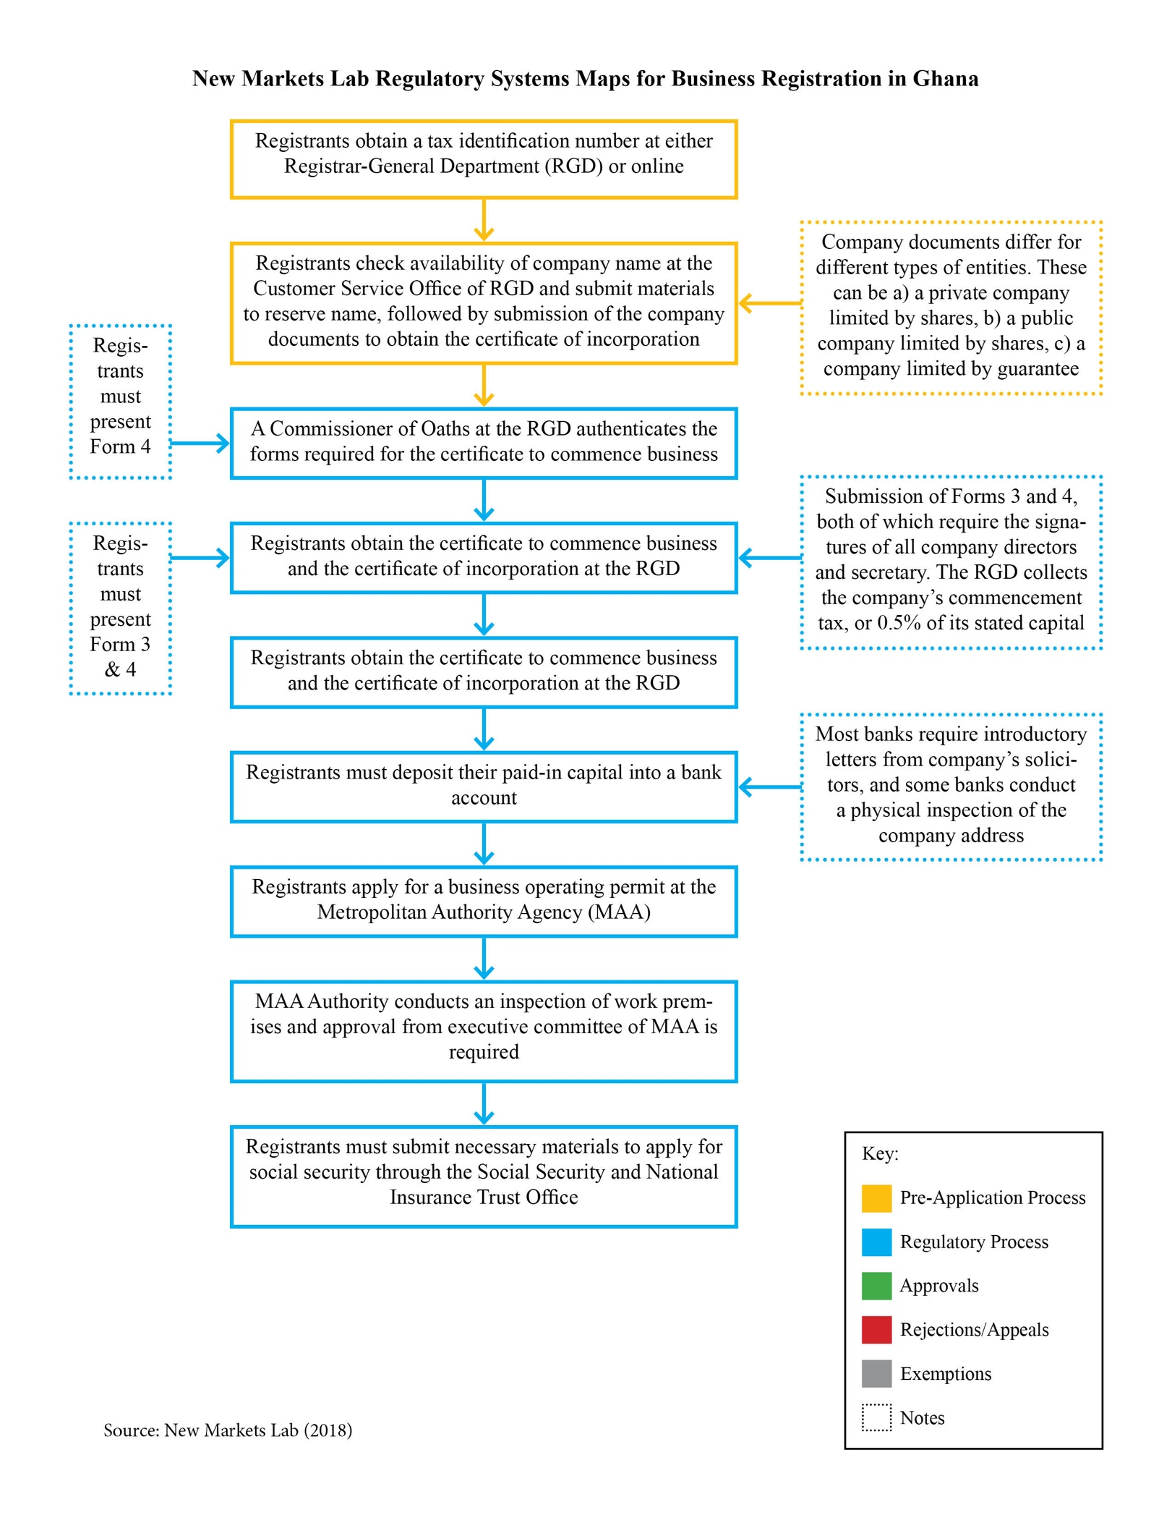

Business Registration in The Gambia
By Jacob Stansell

Key findings
- The Gambian economy relies heavily on tourism, rain-reliant agriculture, and remittances.
- The economy has a very high ratio of debt to Gross Domestic Product (GDP), but projections show this ratio decreasing and inflation leveling off in the near future.
- The Gambia transitioned from an authoritarian president to the current president in 2016; while investment was difficult during this transition, the current government is focused on improving the business climate.
- The Gambia has a high poverty rate of 48.6 percent.
- The Business Registration Act of 2005 seeks to streamline the business registration process in the country.
- To register a business, prospective companies must follow the steps laid out by the Business Registration Office of the Ministry of Justice in Banjul.
- The total cost to register a business is generally low in relation to the share capital of the fledgling company.
- The Gambia Investment and Export Promotion Agency (GIEPA) oversees and regulates the business registration and investment practices within the nation and has streamlined the registration process into a series of simple steps.
- All registered businesses must comply with environmental protection laws, including having an environmental analysis performed of any prospective office sites.
- All registered businesses must contribute to the national social security administration through contributions of 10 percent of employee salaries per month.
- The 2018 World Bank Doing Business Report noted seven procedures required to start a business and estimated 25 days as the time required to register a business in The Gambia. These figures are close to the sub-Saharan averages for both indicators.

Business Registration Process
The Gambia has experienced robust GDP growth in the last decade and has relied heavily on tourism, rain-dependent agricultural production, and remittances. The Gambia has long struggled with poverty, with the latest estimate from 2015 identifying a poverty rate of 48.6 percent of the population. The primary economic issues plaguing Gambian development are related to the lack of diversity in its economy, which is related to the high levels of debt within the country as well as the geographic difficulties the small country faces being landlocked on three sides by Senegal.

Politically, The Gambia has long struggled with authoritarianism, which has hampered its economy. In 2016, the longtime President of The Gambia, Yahya Jammeh, refused to concede an electoral loss to current President Adama Barrow. Jammeh had ruled the country with greater authoritarian power in recent years, and his refusal to leave threw The Gambia into political and economic turmoil. The current administration is seeking to expand business investment within Gambian borders.

Legal Framework
The Constitution of The Gambia, created in January of 1997, makes no direct reference to business development or to an individual’s freedom to contract. The issues currently surrounding business development in The Gambia are less legal and more economic; the country is struggling to attract businesses and spur economic growth. As recently as June 2017, the International Monetary Fund (IMF) found the Gambian economy to be in external debt distress, meaning that it owes its international creditors such as the IMF and International Development Association (IDA) a great deal of capital in relation to its gross GDP. Despite this analysis, the IMF has projected that The Gambia’s debt-to-GDP ratio will fall in coming years and that inflation will become manageable as the country turns a corner from the political and economic turmoil stemming from its choppy presidential transition.

Registration Process
The government agency which oversees business investment and development is the Gambia Investment and Export Promotion Agency (GIEPA). The mission of this agency is to be the point of contact for individuals and businesses wishing to invest in The Gambia and to foster a conducive environment in which businesses and investment may thrive within the country’s borders. The GIEPA is responsible for the business registration process within The Gambia and has streamlined the process into several simple steps, which are discussed in detail below.

First, the prospective business must draft a memorandum and Articles of Association which outline the structure and goal of the business. A photocopy of government identification for all initial shareholders must also be produced. Second, the prospective business must visit the Business Registration Offices at the Ministry of Justice in Banjul, the Gambian capital. At this office, the business must (1) obtain a registration form for no charge; (2) reserve a unique company name for a fee of roughly GMD 480 (USD 10); and (3) obtain a Tax Identification Number (TIN) for a fee of roughly GMD 50 (USD 1). The third and final step in the business registration process is to submit a complete registration form with a registration fee of roughly GMD 1000 (USD 21) as well as an incorporation fee based on the share capital of the business at the time of registration. If the business has a share capital that is less than GMD 500,000 (USD 10,400), the incorporation fee is GMD 10,000 (USD 210); if the capital is between GMD 500,000 and 1,000,000 (USD 10,400 and 20,800), the incorporation fee is GMD 15,000 (USD 310); if the capital is between GMD 1,000,000 and 10,000,000 (USD 20,800 and USD 207,900), the incorporation fee is GMD 20,000 (USD 415); and if the share capital is greater than GMD 10,000,000 (USD 207,900), the incorporation fee is GMD 25,000 (USD 520). After all required documents and accompanying fees have been submitted, the process is generally completed within one day.

In addition to these steps, there are several other actions which must be taken in the business registration process in compliance with the Business Registration Act of 2005. Prospective companies must (1) notarize any and all company statutes for an average cost of roughly USD 3; (2) register employees with the Social Security and Housing Finance Corporation for no cost, but submit as required a five percent monthly contribution by the employee and ten percent by the employer to the administration; (3) obtain an operational license from the respective municipality in which the business is registering, for a fee of roughly USD 105; and (4) create a company seal for a cost of USD 200. Businesses must comply with the environmental regulations put forth by the Gambian government as well as all regulations of labor and social security contributions.

Environmental Assessment
The Gambia enacted The National Environment Management Act (NEMA) in 1994 to create a general framework for environmental protection in the nation. This legislation mandates that businesses must complete an Environmental Impact Assessment (EIA) in compliance with the regulations and procedures of the National Environment Agency (NEA). As a part of the EIA, a comprehensive environmental impact study is carried out in a manner dependent on the type of business project which will be undertaken. The categories of businesses for which environmental impacts are assessed include manufacturing and processing industries, mining and on-site mineral processing, road infrastructure, solid waste disposal, large agricultural projects, fisheries and aquaculture, and tourism development projects. Depending on the type and scope of the individual project, the environmental analysis will address anything from hazardous waste disposal to physical impact on the topography and the health of surrounding populations. At the conclusion of the EIA, any mitigating measures put in place by the business to protect the environment will be considered and a framework for further monitoring and evaluation will be established.

Summary of Registration Process
- Submit Memorandum and Articles of Incorporation, with photo ID of all shareholders.
- Obtain a Registration Form from the Single Window Business Registration Offices at the Ministry of Justice in Banjul or the Kanifing Municipal Council.
- Reserve a Unique Company Name (GMD 480)
- Obtain a Tax Identification Number (GMD 50)
- Submit a complete registration form with a registration fee (GMD 1,000) and applicable incorporation fee as below:
  - If Share Capital is less than GMD 500,000, pay GMD 10,000
  - If Share Capital is between GMD 500,000 and 1,000,000, pay GMD 15,000
  - If Share Capital is between GMD 1,000,000 and 10,000,000, pay GMD 20,000
  - If Share Capital is greater than GMD 10,000,000, pay GMD 25,000
- Complete an Environmental Impact Assessment (EIA) with the national government.

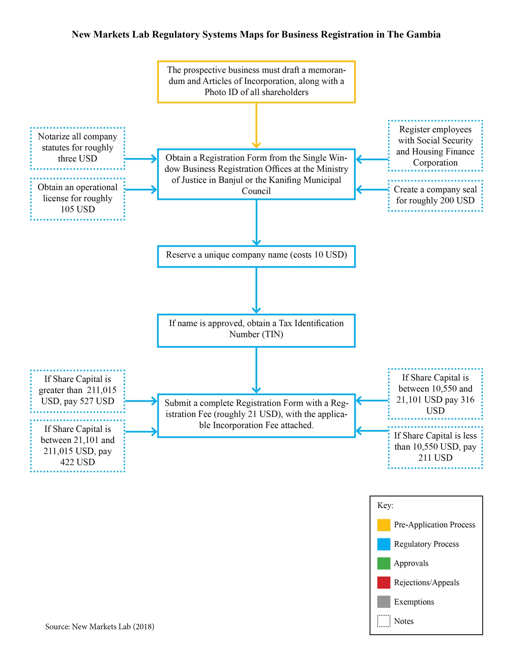

Registering a Business in Kenya
By Prianka Mohan

Key Findings
- Kenya is a lower middle economy and is the third most competitive economy in Africa after Mauritius and Rwanda.
- Kenya has introduced a number of changes in the recent past, transferring a number of its services to online portals.
- The online portal eCitizen has been created as a one-stop portal for business registration.
- In addition to eCitizen, the Kenyan government has also created a number of other websites that provide details and assistance for licensing and investment-related procedures.
- The Business Registration Service Act, 2015 created the Business Registration Service which has streamlined the business registration process.
- The business registration process differs slightly for sole proprietorships and partnerships compared with limited liability partnerships and companies. Further, based on the county in which the business is set up and the sector, the business license will differ and is granted by the particular county government.
- The authorities involved in the business registration process in general are the Registrar of Companies, the county governments, the Kenya Revenue Authority, the National Social Security Fund, and the National Hospital Insurance Fund.
- As per the 2018 World Bank Doing Business Report, there are six procedures required to start a business and estimates 25 days as the time required to register a business in Kenya. These figures are close to the sub-Saharan averages for both indicators.

Business Registration Process
Kenya is a lower middle-income country with a Gross National Income (GNI) per capita of USD 1,380. The World Bank Doing Business index ranks it 80 out of 190 economies. For ease of starting a business, however, Kenya is ranked at 117 out of 190 economies. Kenya’s most dominant economic sector is agriculture, contributing to nearly a quarter of its total GDP. Further, agriculture accounts for nearly half of its export revenue and employs nearly 7 out of 10 Kenyans. However, the prime driver of GDP growth in recent years has been services.

The Kenya Vision 2030 is the development plan for the period 2008 to 2030 with the overarching vision of making Kenya a globally competitive nation with a high quality of life. The vision is to be achieved through five-year Medium Term Plans focused on three pillars: economic, social and political. Within the economic pillar, Kenya aims to increase GDP growth rates to an average of 10 percent through six key sectors: tourism, agriculture, wholesale and retail trade, manufacturing, business process offshoring, and financial services. One of the strategies for attracting and promoting investment in the country is simplification of the business registration and trade licensing process.

In keeping with this vision, Kenya has made several changes in its business registration process. The aim of these changes has been to increase transparency and, as a result, attract more investment into the country. Multiple laws govern the business registration process in Kenya, as elaborated in the sections below.

Legal Framework
The Business Registration Service Act, 2015 governs incorporation, registration, operation, and management of companies, partnerships, and firms in Kenya. The Business Registration Act came into force on 6 November 2015, and the goal for implementing it was to simplify the business registration process in Kenya. The Business Registration Act makes it mandatory to use the eCitizen portal for all company and business registrations. The business registration process is slightly different for companies than for other entities such as sole proprietorships, partnerships, and limited liability partnerships. Companies have more detailed requirements, while other business registrations are not as involved.

Among the other key changes to the business registration process in Kenya under the Business Registration Act, was the establishment of a Business Registration Service (Service) with the key task of undertaking businesses registration, and maintaining records and data on registrations. The headquarters of the Service is in Nairobi, and there are branches in every county in Kenya to ensure reasonable access. Prior to the Service being created, the State Law Office was responsible for business registration.

The Service is governed by a board of directors (the Board). The Board consists of a chairperson, the Solicitor-General or his representative, the Principal Secretary in the Ministry responsible at the particular time for trade matters, the Principal Secretary in the National Treasury, the Registrar-General appointed by the Board, and four other members appointed by the Attorney-General. The Board is tasked with formulating, reviewing, monitoring and evaluating the performance of the Service, among other things. The chief-executive of the Service is the Registrar-General. The Registrar-General is tasked with implementing decisions of the Board, day-to-day administration and management of the Services’ affairs, among other things.

The Companies Act, 2015 (“Companies Act”), along with the Companies Act Regulations 2016, governs the incorporation, registration, operation, management and regulation of companies. Specifically, it regulates limited, unlimited, private and public companies.

The Registration of Business Names Act regulates the naming of firms, sole proprietorships, and corporations. As noted above, the procedure for registration of names of business is managed online through the eCitizen portal. The Registrar-General appointed under the Registration of Business Names Act is the authority that assess the application filed. For sole proprietorships and partnerships, there are no other legislations that govern their registration; however, the Limited Liability Partnership Act governs the registration and management of Limited Liability Partnerships (LLPs).

In addition to the above legislations, a business permit is required for all businesses. The exact requirements will vary depending upon the location of the business, type of business, number of employees, and so forth. Further, companies and LLPs are also obligated to adhere to social security and health insurance requirements.

Online Portals
The Kenyan government is undertaking efforts to improve the ease of doing business by simplifying the business registration process and improving transparency. One of the key steps is the introduction of online portals that not only avenues for registration and submission of documents for business registration but also provide details on the necessary documents and procedure.
As noted above, the eCitizen portal is the first step for registration of companies, sole proprietorships, partnerships, and LLPs. Registration with eCitizen is necessary to undertake the registration of the name of the entity.

Other than eCitizen, two other portals provide assistance on the registration process, namely eRegulations Kenya and e-Registry. The eRegulations Kenya portal is maintained by the Kenya Investment Authority, which was set up with the aim of facilitating new investments in Kenya. It has a tab setting out step-by-step procedures for starting various types of businesses in Kenya. Like the eRegulations Kenya portal, the e-Registry contains exhaustive details on particular licenses required based on the type of industry and location of a business. The overarching aim of the portal is to improve transparency, and, as a result, reduce risks and uncertainty for businesses. According to its website, at present, it contains information on 400 licenses and permits required by various local governments.

Sole-proprietor and Partnership Registration Process
With the introduction of the online system, the business registration process has been simplified significantly. The steps for registration of a sole proprietorship or partnership are similar. The first step is registering with eCitizen by providing contact details, an email address and a photo. On completion of the process, the applicant will receive an account activation code. There is no charge for this process, and it can be completed within 10 minutes.

The next stage is conducting a business name search. Based on the conditions under the Registration of Business Names Act, registrants must reserve a business name. Upon completion of this stage, the registrant receives a name search and reservation application. The charge for undertaking the search and reservation is KES 100 (USD 1), with a convenience fee of KES 50 (USD 0.5). Within one day, the registrant receives an approval or rejection of the business name reservation application from the Registrar of Companies. The application may be rejected if another business already has the same name or if the name is contrary to requirements under the relevant legislation.

Upon getting an approval of the business name, the registrant then proceeds to register the business. This is done through the eCitizen portal again and, upon completion of the process receives a certificate of registration. A statement of particulars providing details on the name of the business, nature of business, date of commencement, address of business and details of the proprietor(s) will need to be provided. Further, a Personal Identification Number (“PIN”) is also provided by the Kenyan Revenue Authority. For a sole proprietor, the PIN will be that of the individual proprietor, but for partnerships, the PIN may be that of an individual or an artificial person which is the business. The cost for filing the application for registration is KES 800 (USD 8), with a convenience fee of KES 50 (USD 0.5). The process takes up to 20 days to receive the certificate. The last step for conducting business would be acquiring the necessary licenses, based on the location and nature of business. The various county governments are responsible for issuing business permits.

LLP Registration Process
The steps for registration of an LLP are slightly different. The process above upto receiving the approval of the business name from the Registrar of Companies is the same. Upon getting approval of the business name, the registrant then proceeds to register the LLP. This is done through the eCitizen portal, and, upon completion of the process, the applicant receives a certificate of registration. A statement of particulars providing the name of the partnership, the nature of the business, the proposed registered office, and details of each of the partners and managers will need to be provided. In addition, each of the partners and managers are to submit their identity cards for locals or passports for foreigners and PIN. The registration fee is KES 25,000 (USD 250), and the process takes up to 10 days. The next stage is obtaining the necessary license. As noted above, requirements will primarily depend upon the location and type of business.
On receiving the necessary licenses, a sole proprietorship or partnership would complete the registration process. As an LLP, registration with the National Social Security Fund (NSSF) and the National Health Insurance Fund (NHIF) is required. At the time of registration with the NSSF, the registrant would need to provide the certificate of registration and the business license. The documents may be submitted at any NSSF branch. Upon completion of the process, the LLP will receive an Employer Registration Number and a Certificate of Registration. The process could take around one day. Similar to the social security registration, LLPs are required to register with the National Health Insurance Fund (NHIF) at an NHIF branch. Upon completion of the process, the LLP will receive an Employer Code. The process takes around 2 days.

Company Registration Process
The process for registration of a company is fairly similar to the process elaborated for an LLP above. The only differences lie in the stages relating to company and tax payer registration as well as the costs.
Upon obtaining the business name reservation, the next stage is company registration. In registering the company, certain forms are required: (1) Form CR1, which is the company registration form containing details on the type of company, address, details of the directors, secretary and authorized signatory, and share capital; (2) Form CR2 or CR3, which is the Memorandum of Association of the company, depending on whether the company is limited by shares or guarantee; Form CR8, which is the notice of address of the company; and (4) Statement of nominal capital of the company.
Upon completion of the process, the company will receive a certificate of incorporation. Thereafter, the company will need to get a company PIN, by registering on the Kenya Revenue Authority website. Upon completion of the process, which takes around 10 days, the company receives a PIN certificate. The last stages are obtaining necessary business licenses, social security and NHIF registration, which is similar to that of an LLP.

Summary of Regulatory Process
- Create an account on eCitizen
- Apply and pay for business name search
- Obtain business name reservation from Registrar of Companies
- Submit complete form for business registration based on business name approved on eCitizen portal
  - For a company, submission of CR1, CR2, CR8 and statement of nominal capital are required.
  - For other business forms, a statement of particulars is to be submitted.
- Obtain certificate of registration from Registrar of Companies
- Obtain business license/permit from county government
The process is completed at this stage for sole proprietorships and partnerships. For LLPs and companies, the additional steps are:
- For companies only, a company PIN from Kenya Revenue Authority is required
- Obtain National Social Security Fund employer registration
- Obtain National Hospital Insurance Fund employers code

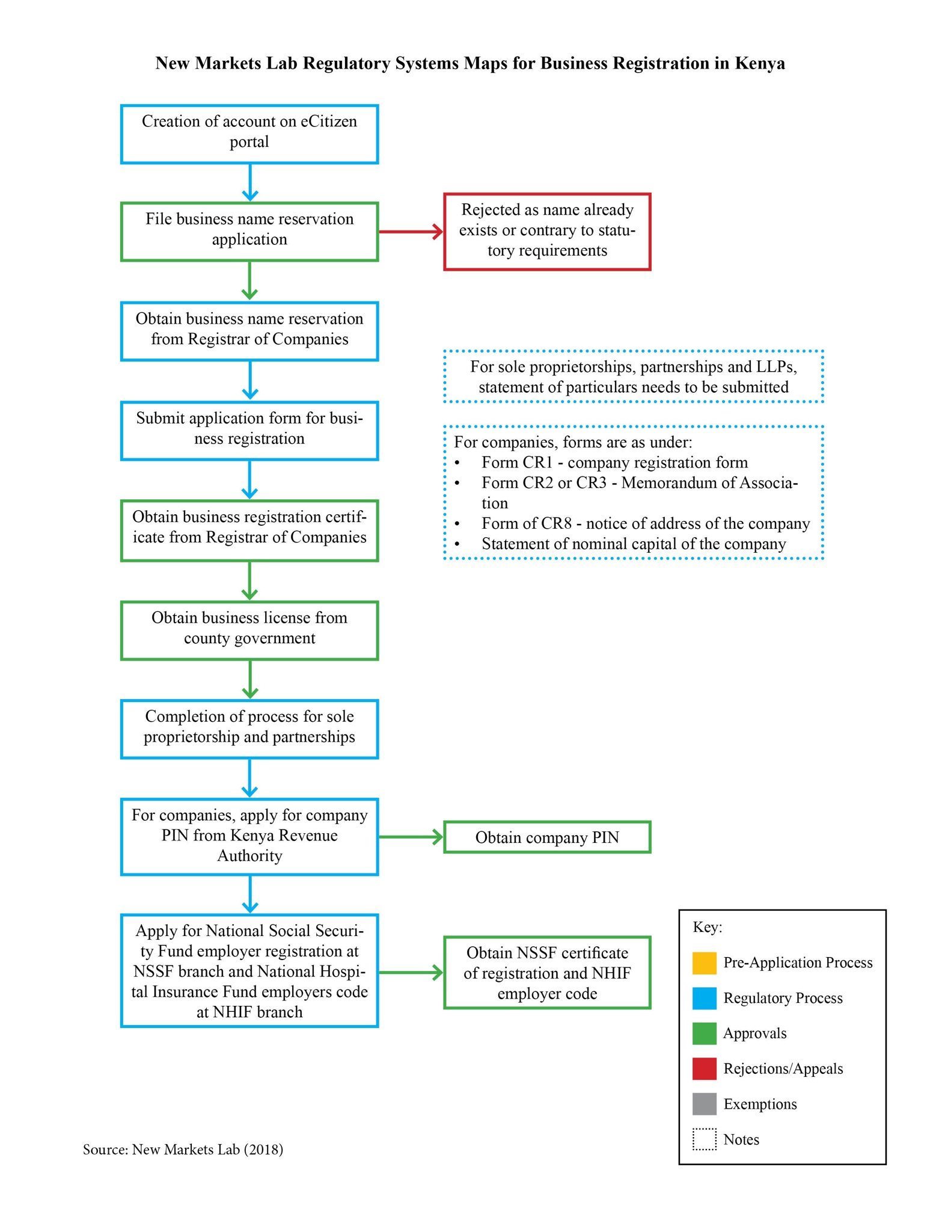

Business Registration in Nigeria
By Miao Pan

Key Findings
- Nigeria is among the largest economies in Africa, with the economic growth rate in 2017 at averaging about 1 percent but expected to strengthen to 2.8 percent with the government implementing a new growth plan.
- The
- The primary legal sources for business registration are the Constitution of Nigeria 1999, the Companies and Allied Matters Act 2004, and the Companies Regulation 2012.
- For doing business in Nigeria, the Corporate Affairs Commission (CAC) is the governmental body responsible for registering companies.
- CAC launched its online registration on February 2, 2015, which makes the business registration process more efficient and convenient.
- The most common business structure is the private limited liability company, which is commonly used among small and mid-size enterprises (SMEs).
- As per the 2018 World Bank Doing Business Report, there are eight procedures required to start a business and estimates 18 days as the time required to register a business in Nigeria. While the number of procedures is similar to the sub-Saharan average, the estimated time is significantly lower than the sub-Saharan average of 24 days.

Business Registration Process
The Nigerian economy is the largest African economy, with the petroleum sector accounting for nearly 90 percent of its export earnings. Oil and gas is the main source of government revenue and it also has a large service sector supporting the industry. Despite being an oil rich country, high rates of corruption have restricted the extent of revenue that could be gained from the country’s resources. Though, the 2015 election has been regarded as a positive change for Nigeria. President Buhari came to power in May 2015 and has sought to increase transparency in the economy and diversify the economy away from oil. The country, however, had period of recession in 2016 but has recovered in 2017.

The World Bank Doing Business index ranks it at 145 out of 190 economies. Specifically, for ease of doing business, its ranking in 2018 is 130 which is an improvement from the previous year ranking of 138. A major reason for the positive change is the improvement of online portals for the registration of documents.

Legal Framework
In Nigeria, legislative power is vested federally in the National Assembly, which is empowered to make laws on any matter included on the Exclusive Legislative lists set out in Part I of the Second Schedule to the Constitution. The incorporation, regulation and dissolution (winding-up) of corporations, for example, are matters solely under federal legislative power. Accordingly, in 1990, the federal government enacted the Companies and Allied Matters Decree, now re-titled the Companies and Allied Matters Act (CAMA), as a primary legal source to regulate the formation, incorporation, management and dissolution of companies.

The Corporate Affairs Commission (CAC) was established under CAMA and is the governmental body responsible for registering companies. Besides CAMA, the Companies Regulation 2012 also applies. The Regulation was drafted with a view to codify some established practices and conventions not properly addressed by the substantive provisions of the CAMA.

In order to do business in Nigeria, a foreign investor must create a separate entity in Nigeria. The law permits exemptions to be granted by the Federal Executive Council for creation of a separate entity, but however this is rarely granted and is revocable. Therefore, foreign investors most often register their businesses.

The CAMA recognizes the following business forms: (1) limited liability company (public or private); (2) company with unlimited liability; (3) company limited by guarantee; (4) incorporated trustee; and (5) registered business name. The most common structure for a profit-making enterprise is the private limited liability company. Its advantages include a straightforward incorporation process, profit distribution to shareholders, limited liability to shareholders, and being subject to fewer regulations than other available structures. Accordingly, this guide will focus on registration of a private limited liability company in Nigeria with respect to small and mid-sized enterprises.

Registration Process
CAMA requires that a company have at least two directors, and a company’s directors must be identified at the time the incorporation forms are filed. A minimum of two and maximum of fifty members are required to start a private business. The CAC online system was launched on February 2, 2015. Registration of a business can be done either on-site with CAC or online. In general, the website lists four stages for registering a business: (1) public search (search for a name to register); (2) reserve a name (submit your preferred business name); (3) pre-incorporation (register a company with your name availability code); and (4) post-incorporation (file changes to your existing business). A user guide is also available on the website, which includes screenshots to aid the business user in navigating the site. All documents delivered to CAC must be in English. Incorporation fees are listed under the Companies Regulation 2012.

The first step to register a company in Nigeria is to conduct a name search on the CAC database. A name reservation costs NGN 500 (USD 1). In making the payment, registrants can pay online or in person via bank branches. Upon successful payment, registrants receive a response within 24 hours. If the proposed name is approved with a name availability code, registrants proceed to the next stage of the registration; if not, then the entire process is repeated by submitting another name.

The next step is to complete registration by preparing CAC forms and other necessary documents. The CAC forms are referred to as the “set of incorporation forms” which is comprised of: CAC 2 (statement of share capital and return of allotment of shares), CAC 2.1 (particulars of the company secretary), CAC 3 (notice of situation or change of registered address), CAC 4 (declaration of compliance with CAMA requirements), and CAC 7 (particulars of directors). However, the CAC introduced the new form CAC1.1 in place of CAC 2, CAC 2.1, CAC 4, and CAC 7.

On completing CAC1.1, the Memorandum and Articles of Association must be prepared. The business founder then signs the CAC 1.1 form before a Notary Public for a fee of NGN 4,000 to NGN 5,000 (USD 11 to 14). Alternatively, it may be sworn to at any of the recognized courts in the country before a Commissioner for Oaths for a fee of NGN 500 (USD 1).

To prepare the requisite incorporation documents prior to the filing, the registrant must get completed CAC 1.1 form and Memorandum and Articles of Association stamped by the Federal Inland Revenue Service. Alternatively, the registrant may file the required information online, pay the incorporation filing and stamp duty online, and upload the scanned documents. Payment of stamp duties only applies to “company” registration. The stamp duty payable on share capital is 0.75 percent and NGN 500 for each additional Memorandum and Articles of Association stamped.

Note that during the registration process, the registrant may be required to submit a certificate of proficiency if the registration relates to professional services, such as legal services, accounting services, or engineering services. In order to complete this registration, the registrant will need to disclose such proficiency, for example, a Bar Certificate to register a legal service. If the registrant does not possess the necessary certificate, he or she shall avoid using a name that implies professional services.

To complete the registration process for a private company, the CAC requires registrants to prepare the signed scan copy of the pre-registration documents as follows:
- Form CAC 1.1; (A copy of either the data page of passport, driver’s license or national identity card of every individual director, subscriber and secretary must be attached to this application.);
- Memorandum and Article of Association;
- Recognized form of identification for director(s)/subscriber(s);
- Stamp duty certificate;
- Evidence of payment to CAC; and
- Secretary Proficiency certificate (where applicable).

Registrants may either file these documents with the CAC or online. Upon uploading the above documents in PDF format, the registrants click the submit button and wait for the approval of the registration. The incorporation fees are:
- NGN 500 (USD 1) as the incorporation fees
- NGN 3,000 (USD 8) for certified true copy of Memorandum and Article of Association
- NGN 2,000 (USD 6) for certified true copy of form CAC 1.1
- Registration for private company above NGN 1 million (USD 2780) and up to NGN 500 million (USD 1388890): NGN 5,000 (USD 14) for every NGN 1 million share capital

If approved, registrants bring the original copies of the documents uploaded to the selected CAC office in exchange for a certificate and the certified true copies of the documents. The registered company then must create a common seal.

Summary of Regulatory Process
- Conduct name search on Corporate Affairs Commission website and reserve a unique company name
- Complete the Form CAC 1.1, prepare and print the Memorandum and Article of Association and have them stamped by the Federal Inland Revenue Service.
- Sign the declaration of compliance (Section E of Form CAC 1.1) before a Notary Public for a fee of NGN 4,000 to NGN 5,000 or alternatively before the Commissioner or Oaths for NGN 500
- Register the company at the Corporate Affair Commission and pay registration fees by submitting:
  - Two copies of the stamped Form CAC 1.1
  - Two copies of the stamped Memorandum and Article of Association
  - Form of identification of the directors, shareholders, and company secretary (driver’s license or national ID or data page of international passport)
  - Certificate of Proficiency (if needed)
  - Stamp duty certificate
  - Evidence of payment to CAC
  - Copy of name reservation of the company
- Alternatively, to combine step 2 and 4, file the required information online, pay the incorporation filing and stamp duty online and upload the scanned documents.
- If the registration is approved online, bring the original copies of the documents uploaded to the previously selected CAC office in exchange for the certificate of incorporation and the certified true copy of the CAC 1.1 and certified true copy of Memorandum and Article of Association
- Make a company seal that would cost NGN 4,000 to NGN 6,000 (USD 11 to 17)

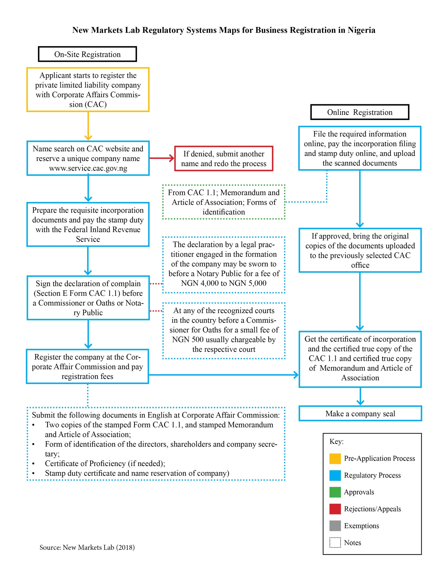

Registering a Business in Tanzania
By Laura Clark

Key Findings
- Tanzania has a large informal sector that the government is seeking to formalize by addressing access barriers and simplifying registration processes.
- Tanzania is ranked 137 out of 190 by the World Bank’s Doing Business index. The Tanzania Five Year Development Plan aims to improve this ranking to 100 by 2020 by easing licensing requirements, simplifying regulations, promoting public-private partnerships, and making startup capital more available.
- The Business Registration and Licensing Authority (BRELA) plays an important role in registering businesses, including name selection and acceptance of the forms required for business registration.
- Other than BRELA, the Tanzanian Revenue Authority, Ministry of Industry and Trade, Local Government Authorities, Workers Compensation Fund, Tanzania Regulatory Authority, Occupational Safety Authority, and Social Security Regulatory Agency are involved in the registration process.
- As per the 2018 World Bank Doing Business Report, there are 11 procedures required to start a business and estimates 28 days as the time required to register a business in Tanzania. Both are higher than the sub-Saharan averages.

Business Registration Process
Out of a population of about 55 million, the active labor force in Tanzania is estimated at just over 26 million. The informal sector in Tanzania is large and untaxed, with 90 percent of homes and businesses unregistered. In Tanzania, there is a large amount of work in the informal economy, because of the ease in establishing a business extra-legally compared to following government procedure. This is a problem for the government because they are trying to build the capacity of the business community. The Property and Business Formalization Program is an effort to incorporate these businesses into the formal sector. Established in 2004, the program was commissioned to address access barriers in property and business opportunities. The program works to convert entities from the informal sector to the formal sector.

Tanzania is hoping to improve its Doing Business Ranking by 2020, and so instituted the Tanzania Five Year Development Plan. With that goal in mind, the government has implemented new policies that will help facilitate business registration. The development plan is designed to improve its Doing Business ranking from its present rank of 137 to 100 by 2020. Tanzania plans to improve its ranking by easing licensing requirements, simplifying regulations, promoting public-private partnerships, and ensuring availability of start-up capital.

Registration Process
Business registration in Tanzania is a complicated process with many steps. When registering a business in Tanzania, the company name must first be approved by the Business Registration and Licensing Authority (BRELA). Applications are submitted by mail or at a local office, by providing three possible names, one of which will be approved by BRELA. If the proposed names are too similar to other registered names, the application will be rejected. If the name is available, the registrant then submits the Memorandum and Articles of Association to BRELA. BRELA provides this name-evaluation and approval service for free and takes about one day to complete. Once the registrant has BRELA approval, she or he must obtain a notarized declaration of compliance. This declaration confirms that the business has approval from BRELA. Notarization takes no more than a day to complete, and varies in cost, based on the notary. It could cost between TZS 10,000 to 50,000 (USD 5 to 20).

The registrant then applies to the Registrar of Companies in Dar es Salaam for company incorporation and obtains the certificate of incorporation. The registrant must submit three forms: (1) Form 14a which contains details of the company directors and secretary, as well as the registered office of the company; (2) Form 14b which a declaratory statement of compliance with all the requirements for formation of the company; and (3) Memorandum and Articles of Association that were approved by BRELA. Forms 14a and 14b are free and are typically processed within three days. This process costs around TZS 337,200 (USD 150). This amount includes the company registration fee, which varies from TZS 95,000 to TZS 440,000 (USD 42 to 194) based on the share capital of the company; filing fee of TZS 66,000 (USD 30); and stamp fees of TZS 6,200 (USD 3) for the original BRELA approved Memorandum and Articles of Association. Lawyers are not required for company registration but are commonly used.

Next, the registrant applies for a taxpayer identification number (TIN) with the Tanzania Revenue Authority (TRA). This registration is free, computerized, and takes about one day to complete. The registrant attaches the certificate of incorporation from the previous step, along with the Memorandum and Articles of Association to the TIN application. To obtain the TIN, at least one of the company’s directors must be present at the TRA to give fingerprints and pick up the number in person. The company must declare their estimated income for that year, which may then be reviewed by the TRA officer.

The business must then obtain a business license from the Ministry of Industry and Trade (MIT) or Local Government Authorities (LGAs), depending on the nature of the business. Though it is individualized and sector-dependent, typically businesses that operate locally apply to the LGAs, while businesses that involve importation or international components register with MIT. The business must submit a licensing application, certificate of incorporation, Memorandum and Articles of Association, proof of Tanzanian citizenship, proof of company premises, and TIN. The licensing process takes six days and costs TZS 1000 (USD 50). If the company is over the threshold income of TZS 100,000,000 (USD 44,000), then the company must also apply for a VAT certificate, issued by the TRA. The registration takes three to five days.

The next four steps run concurrently. Businesses must then register in person with the Workers Compensation Fund (WCF) and the Tanzania Insurance Regulatory Authority (TIRA) for workmen’s compensation insurance. For registration with the WCF, the business must complete a registration form along with details on the business. The firm is required to register regardless of whether the employees are permanent or temporary. This step is free and takes one day to complete.

Businesses must also register with the Occupational Safety and Health Authority (OSHA). On submission of the application form, the OSHA officials conduct an inspection on health and safety. This process takes ten days to complete, and costs TZS 600,000 (USD 260). Once OSHA completes its inspection, it will issue a Certificate of Compliance.

Lastly, the business must also obtain a Social Security registration number from the Social Security Regulatory Authority (SSRA). This takes seven days and is free. Every employer in the formal sector is required to register his/her employees with any of the mandatory schemes, though the employee retains the right to choose which one to register under. There are five mandatory social security schemes in Tanzania, namely: Governmental Employees Provident Fund (GEPF), Local Authorities Pension Fund (LAPF), National Social Security Fund (NSSF), Parastatal Pension Fund (PPF), Public Service Pension Fund (PSPF) and National Health Insurance Fund (NHIF). Each one requires different minimum contributions and provide different benefits.

Summary of Regulatory Process
- Submit three possible names, a memorandum and articles of association to the Business Registration and Licensing Authority (BRELA) for approval of company name.
- On approval by BRELA, notarization of the declaration of compliance.
- Submit approved BRELA approved Memorandum and Articles of Association, application Form 14a (company directors, secretary and office details), and Form 14b (declaratory statement of compliance) to Registrar of Companies.
- Obtain the certificate of incorporation from the Registrar of Companies.
- Apply for Taxpayer Identification Number (TIN) with Tanzania Revenue Authority (TRA). A director of the company must be present to provide fingerprints and get the TIN is person.
- Depending on the business, obtain a license from the Ministry of Industry and Trade (MIT) or Local Government Authorities (LGAs).
- Apply for a VAT certificate with the TRA.

The next four steps run concurrently:
- Register with the Workers Compensation Fund (WCF) and the Tanzania Insurance Regulatory Authority (TIRA) for workmen’s compensation insurance.
- Register with the Occupational Safety and Health Authority (OSHA) and OSHA officials will conduct an inspection of the office premises.
- Obtain a Social Security registration number from the Social Security Regulatory Authority (SSRA).

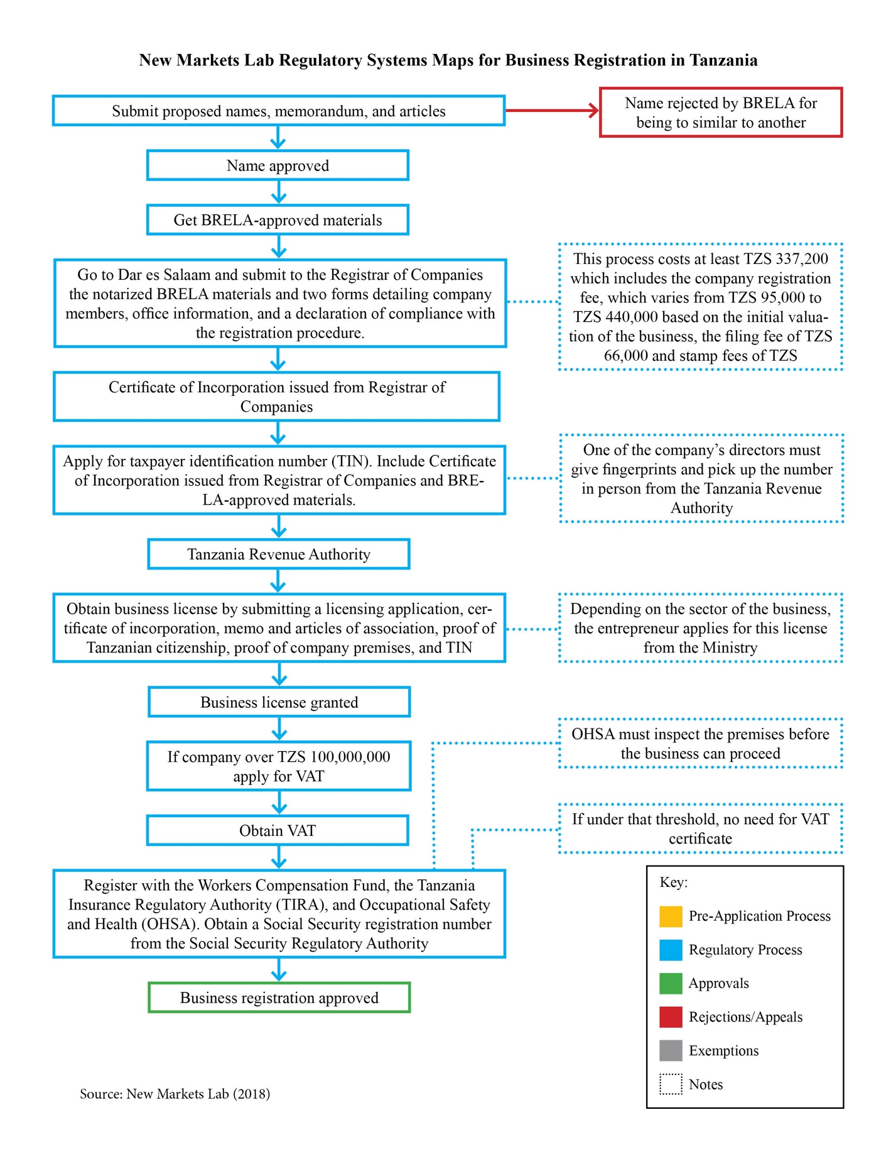

Business Registration Process in Rwanda
By Heesoo Park

Key Findings
- Rwanda has the fewest procedures and fastest processes in East Africa and ranks 41 in World Bank Doing Business ranking.
- As per the 2018 World Bank Doing Business Report, there are five procedures required to start a business and estimates four days as the time required to register a business in Rwanda. The time required for register a business in Rwanda is not only lower than the sub-Saharan average of 24 days but even lower than the OECD high incomes country average of eight. Similarly, even the number of procedures for registration of a business in Rwanda is in the range of the OECD high incomes country average of 4.9.
- Rwanda’s business registration is generally covered by Law No. 07/2009 of 27/04/2009 relating to companies. Four types of companies are recognized (company limited by shares, company limited by guarantee, company limited by both shares and guarantee, and unlimited companies), with all following the same online registration procedure.
- Registration can be done online or by visiting the Office of the Registrar General, which is a department within the Rwanda Development Board.
- Rwanda provides a single-point integrated service (one-stop shop). Once the business registration is complete, the next steps of tax registration with the Rwanda Revenue Authority, employer registration with the Social Security Fund of Rwanda, and notification of business activity to the National Institute of Statistics of Rwanda can all be completed in the same location.
- Business Registration is concluded by the issuance of a business registration certificate. This is a unique enterprise code that acts as an identifier of the business in relation to any public agency. The Enterprise/Company code is also the tax identification number (TIN).

Business Registration Process

Legal Framework
Once registration is complete, tax registration with the Rwanda Revenue Authority, employer registration with the Social Security Fund of Rwanda and notification of business activity to the National Institute of Statistics of Rwanda are all simultaneously finished. At the end of the process, the applicant will be issued with business registration certificate which has a unique enterprise code that acts as a unique identifier of the business in relation to any public agency. The Enterprise/Company code is also the tax identification number (TIN).

Sole-proprietorship Registration Process
Businesses can register online or at the Office of the Registrar General, which is a department within the Rwanda Development Board (RDB) located in Kigali. Businesses can be registered as a sole proprietorship, a company or a foreign subsidiary/branch. The procedures vary for sole proprietorships and for companies. The following documents are required for sole proprietors:
- Registrants national ID number (for Rwandans) or passport (for foreigners);
- Sole trader or authorized representatives contact details and email account
- Registrant’s passport photo; and
- Filled in application form.

On submitting the necessary documentation, the business will receive an electronic certificate of registration with a company code from the Rwanda Development Authority. This code will serve as the tax identification number and the social security number as well.

Company Registration Process
Rwanda’s general business registration process is covered by the Law No. 07/2009 of 27/04/2009 law relating to companies (Law No. 7). The law recognizes four types of companies: limited by share, company limited by guarantee, company limited by both shares and guarantee, unlimited company, and they all follow the same online registration process.

The first step in business registration is to obtain an electronic signature. This e-signature is required to log into the system for registration. To obtain an e-signature, applicants must provide a scan of their ID cards with the application. A registration number is provided, which allows the user to proceed to online registration. This number is also the Tax Identification Number (TIN) and value added tax (VAT) number for the company. Since this is an online process, there is no cost to it, and it can be finished within a day.

The second step after acquiring e-signature is to begin the registration process. Applicants must first check for uniqueness of the company name, then company documents should be filed to obtain an e-copy of the registration certificate as well as the copy of their notification on tax duties and obligations. VAT registration may also be completed online, and anyone whose taxable activities exceeded RWF 20,000,000 (USD 23,000) of the previous fiscal year or RWF 5,000,000 (USD 5700) in the last calendar quarter must register for VAT at the RDB within seven days from the end of the year or from the end of an equal quarter as mentioned above. The required documents for this are a duly completed online application and proof of identity for each signatory of the memorandum of association form. For Rwandans, a scanned copy of the national ID with the name of the designated chairpersons of the board of directors must be submitted.

The third step is to purchase an electronic billing machine. Every company must purchase an electronic billing machine from a certified supplier. Every invoice must be printed with this electronic billing machine, which costs around RWF 150,000 (USD 175).

The fourth step is to register employees at the Social Security Office. Employers must go to the Social Security Office to provide the employees’ information on a flash disc. This information in uploaded within two hours and filing of returns is done quarterly. This procedure has been available online since December 2013.

The final step is to obtain a Trade License, referred to as the “patentee.” Every company needs to pay for the patentee, and the cost depends on the company’s annual turnover and type of business.
The new company must go to the tax administration at the sector level where the company is located.

Environmental Impact Assessment
An Environmental Impact Assessment (EIA) is required for government approval of major projects, activities, and programs in Rwanda under the Organic Law.

The first step in obtaining an EIA is to create a user account and submit the EIA application online. This takes less than a day, and the registrant will be able to open an account and apply instantly. Required documents that must be prepared are the following:
- Proof of identity of the person in charge of the project;
- Contact details and email account of the person in charge of the project;
- Complete application form;
- Project brief;
- Panoramic view of the site (optional);
- Perspective and site layout plans;
- Proof of land ownership which is any legal document that proves the rights of the project developer on a given piece of land; and
- Location maps
After submission of the application, a designated representative (focal person) and an appointment for the site visit will be arranged. The site visit is an integral part of the screening process to determine whether an environmental impact assessment is necessary at all. The registrant will be informed of the date, time, and any other arrangements regarding the site visit. Other stakeholders, such as representatives of the Rwanda Environmental Management Authority, district environmental officers, land officers, and so forth, may join. The registrant, or any other representative with the knowledge of the project and the site, has to be physically present and should be able to show the boundaries of the site. The inspection itself may take anywhere from 30 minutes to 6 hours. The wait time until the next step is about 1 day to 15 days.

Once approved for an EIA, the terms of reference, transmission of the terms of reference, and list of EIA experts will be uploaded in the online application system. Not all sites will require an EIA depending upon the level assigned by the focal person after a full assessment. There are three different levels that can be assigned, level 1 to level 3. If determined level 3, the site will require a full EIA, and the applicant will receive the terms of reference for the EIA study and a list of experts to carry out an EIA study. If determined level 2, the site will require a partial EIA, and the applicant will receive letter of approval and an environmental management plan with necessary guidelines. If the site is determined level 1, this means a non-objection clearance, and the site will not require an EIA; the process will end here. After the inspection, EIA study reports will be produced. This process may take from a single day to maximum of five days.

The final step is to submit the EIA study report. After submission and verification, the assigned focal person may have some comments and request additional information. In such cases, the applicant will be notified via email and SMS and he/she will be requested to send any additional information through the online application system.
For large projects, it might take more than 20 days after the submission of the EIA report to obtain an EIA Certificate. In this case, the client will be informed at the time of submission of the EIA report. The assigned focal person will call the applicant to let him/her know when the EIA Certificate is ready. This process assumes that the land and the building that the entrepreneur wants is already registered and free of title dispute.

Summary of Regulatory Process
For registration of a company
- Obtain electronic signature by providing scan of ID with application.
- On obtaining a registration number, proceed to registration process.
- Identify a unique company name.
- Submit online application, proof of identity for each signatory of the memorandum of association at the Rwandan Development Board to get a registration certificate and VAT registration.
- Purchase electronic billing machine from a certified supplier.
- Register employees with Social Security Office.
- Obtain a Trade License.

For Environmental Impact Assessment
- Create a use account and submit EIA application online.
- Receive confirmation from designated representative for site visit.
- Registrant or other representative must be present during site visit to show the boundaries of the site.
- On approval from EIA, focal person uploads the terms of reference and list of EIA experts with the application.
- Depending on the level assigned by the focal person, extent of EIA approval is assessed.

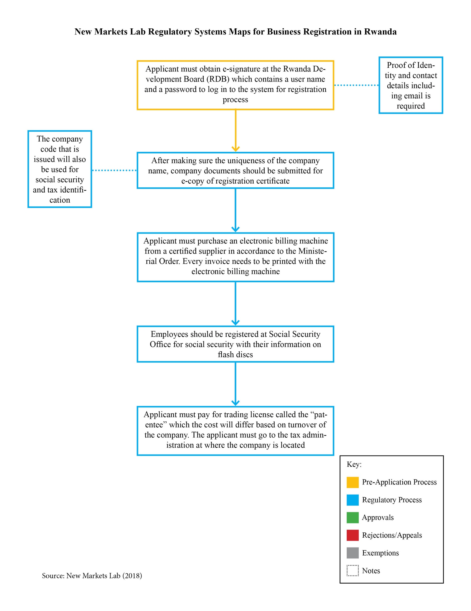

Business Registration in Uganda
By Natalie Gallon and Thinlay Chukki

Key Findings
- The business registration process broadly consists of 8 steps in Uganda.
- A majority of the registration process can be done online through the One Stop Centre eBiz that has been created to serve as a “single point of entry” for registration of businesses.
- In addition to the eBiz portal, Uganda also provides assistance through a number of other online portals that assist local and foreign person looking to set up businesses in Uganda. For example, the website of the Uganda Registration Services Bureau provides details online for each stage of the business registration process with the procedure, time and cost for each stage. Further, it also has a toll free number for any assistance.
- The main agencies involved in the registration of business in Uganda are the Uganda Registration Services Bureau, the Uganda Investment Authority, Uganda Revenue Authority, and Environment Management Agency.
- Uganda currently ranks at 122 in the World Bank Doing Business index. However, for ease of doing business for 2018 is at 165.
- As per the 2018 World Bank Doing Business Report, there are 13 procedures required to start a business and estimates 24 days as the time required to register a business in Rwanda. The time required for register a business in Uganda is the same as the sub-Saharan average, but the number of procedures is twice the sub-Saharan average.

Business Registration Process

Legal Framework
Uganda’s One Stop Centre eBiz is an inter-institutional project that integrates services of different agencies to access necessary government services “through a single point of entry.” The Uganda Investment Authority (UIA), Uganda Registration Services Bureau (URSB), Ministry of Lands, Housing & Urban Development, Uganda Revenue Authority (URA), Kampala Capital City Authority (KCCA), Directorate of Citizenship and Immigration Control, and National Environment Management Authority are all partners in the eBiz project. Currently, the only services offered through eBiz are the business name search, business name reservation, environment impact assessment, investment license application, and land title verification, but more services will be added as the program develops and more users become familiar with its process.

The Companies Act, 2012 recognizes three types of companies, and applies whether the company is public or private: 1) a company limited by shares (i.e., a company where the liability of its members is limited based on the number of shares held by them); 2) a company limited by guarantee (i.e., a company where the liability of its members is limited by the amount they contribute to the assets of the company if it is being wound up) and 3) an unlimited company (i.e., a company not having any limit on the liability of its members). These companies all follow the same business registration steps outlined below.

Registration Process
The process for registering a business in Uganda consists of eight general steps: 1) reserving a business name; 2) registering the company; 3) obtaining an investment license; 4) applying for a tax identification number; 5) obtaining a trading license; 6) undergoing an environmental impact assessment; 7) registering with the National Social Security Fund; and 8) creating a company seal.

The first step for registering a new company is applying for the reservation of a business name with the URSB. The registrant submits three name options on the application form for name reservation, which are then subject to search in the business registry database. The fee for the registration is UGX 20,000 (USD 5) and the search/inspection fee is UGX 2,000 (USD 0.50). The desired name will be reserved for 30 days, if it passes “the similarity, defensive, offensive, desirability test”. The Registrar of Companies may reserve a name on behalf of a registrant pending registration of a company for at least 30 days and not exceeding 60 days.

Once the business name has been reserved, then the name must be registered. To register a business name, the registrant shall furnish a statement in writing in the prescribed form that contains: 1) the business name; 2) the general nature of the business; 3) the principal place of business; and 4) for a firm, the name, surname, nationality, nationality of origin, and residence, of each of the partners, as well as the corporate name and principle office of every corporation which is a partner; 5) for an individual, the name, surname, nationality, nationality or origin, and residence of the individual; 6) for a corporation, the corporation name and principle office.

The business name may also be reserved using Uganda’s One Stop Centre eBiz for starting a business. Through the One Stop Centre, a new business registrant may download the Name Reservation Form, available online or in a physical One Stop Center at any of the UIA or URSB offices, and then submit it through the online portal.

Once the name is approved, the registrant will then file the forms required for registering a company with URSB. The fees applicable is UGX 50,000 (USD 13) for companies whose share capitals do not exceed UGX 5,000,000 (USD 1,288) and one percent of the nominal share capital for companies whose share capital exceeds UGX 5,000,000. These forms include Form S.18 (Form for Registration of a Company) and Form A.1 (Statement of Nominal Capital); the Memorandum and Articles of Association, formatting for which is provided in the Third Schedule to the Companies Act; and a Form A.2 (Declaration of Compliance with the Requirements of the Companies Act). Additionally, a Form A.9 (location of business) and Form 7 (particulars of directors and company secretary) must be submitted within 14 days after company incorporation. Both Forms A.9 and A7 require an individual filing fee of UGX 20,000 (USD 5). These forms are available on the URSB website. Once the company has been registered, the registrar will issue to the company a Certificate of Incorporation in Form 1 in the Schedule to the Companies Act.

A foreign company that establishes a place of business in Uganda must then deliver to the registrar documents pursuant to Section 252 of the Companies Act, 2012 within 30 days after the establishment of the place of business. These documents include: 1) a certified copy of the charter, statutes or memorandum and articles of the company or other instrument constituting the constitution of the company and a certified translation if not originally in English; 2) a list of directors and secretary of the company, their full names, postal address, nationalities, and business occupation; or a corporate name and principal office address (Gen. Co. Form No. A.19); 3) a statement of all subsisting charges created by the company as described in S. 105(2) (Gen. Co. Form. No. A.20); 4) names and addresses of at least one Ugandan resident to accept service of process or other notices to be served on the company (Gen. Co. Form. No. A.21); and 5) the address of the principal office of the company (Gen. Co. Form No. A.22).

After receiving a Certificate of Incorporation, foreign investors are required to obtain an investment license from the Uganda Investment Authority (UIA). The UIA has imposed a requirement that foreign investors must have a minimum of USD 100,000 in planned investment to secure an investment license. Domestic investors are not obligated to obtain an investment license but are eligible for one if their capital investment exceeds USD 50,000.

The investment license application (UIA Form 1) can be obtained online. The completed form must be submitted to the Uganda Investment Authority in paper or online along with copies of the Certificate of Incorporation from URSB; Articles and Memorandum of Association; a brief project proposal, at least five pages long; evidence of availability of funds to implement the project; land status or proof of physical location for the project; and photocopies of passports of foreign shareholders. The application process is free of charge and takes a maximum of three business days for the license to be issued, as long as the application is complete at the time of submission. The investment license application process may also be completed through the One Stop Centre eBiz service.

After receiving a Certificate of Incorporation (and an investment license, if applicable), businesses must apply for a tax identification number pursuant to the Tax Procedures Code Act, 2014, which requires that any entity liable to pay tax under the Income Tax Act, the Value Added Tax Act, or other Ugandan tax code is required to register with the Ugandan Revenue Authority (URA). The Commissioner will issue a tax identification number upon registration.

A business can apply for a TIN online at http://ura.go.ug by following the link for “Non-Individual Registration” under the eServices tab. On this page, there is a downloadable DT-1002 form (Application for TIN-Non Individual) titled “TIN Non-individual,” which also contains instructions for completing and submitting the form. The applicant may submit the completed form online or at a local URA office and must have a Certificate of Incorporation from URSB to complete the application. The TIN registration process can take between three and 30 days depending on location within the country. The business will also need to apply for value-added tax (VAT) registration if its turnover is expected to be above UGX 50,000,000 (USD 12,938). This application form, available for download on the URA website, should be submitted along with the TIN application but can also be submitted after.

Under the Trading License Act of 1969, a business must possess a trading license before engaging in business relating to any of the trades laid out in the Act’s Schedule (including, for example, retail, wholesale, motor vehicle repair, and hawking). A trading license is not required for a gardener or agriculturalist with respect the sale of his or her own dairy or produce; homemade products made in the creator’s own residence; trade in a market; or the sale of tobacco, cigarettes, newspapers, books, nonintoxicating liquor, or playing cards by the management of a members club to its members in the club premises.

Trade license applications are submitted to the “appropriate licensing authority,” and application fees depend on the trade the applicant wishes to engage in and where. For example, a license application for a money lending and savings institution in the City of Kampala is submitted to the Kampala Capital City Authority (KCCA) accompanied by a fee of UGX 105,000 (USD 27) to UGX 487,500 (USD 126), depending on a grade that corresponds to the division where the business is located. To submit a license application to the KCCA, an applicant will create an account with the online City Operator Identification Number (COIN) service and then fill out an online application. As part of this application, businesses must provide a TIN; two forms of identification (either for proprietors or partners in sole proprietorships or partnerships, respectively); registration certificate for sole proprietorships and partnerships or a Certificate of Incorporation for a company; a statement of particulars for sole proprietorships and partnerships or a Form 7 and Form 9 for companies; and a rent receipt for new businesses. For a trade license to be issued, a KCCA officer will assess the business premises and ensure they are appropriately located and compliant with health and hygiene standards.

The Uganda Business Licensing Information Portal, maintained by URSB, allows users to obtain information regarding what licenses and/or permits are needed for their business and what documentation is required for that license or permit.

In addition, as of 2014, foreign traders must go through the additional step of receiving a certificate of approval for non-citizens to conduct trading in Uganda from the Ministry of Trade, Industry and Cooperatives (MTIC). According to MTIC’s press release regarding this requirement, applications and Certificates of Approval shall be processed within 48 hours. The application form is available online which must be submitted to MTIC along with a Certificate of Incorporation; Company Form 7; previous trading licenses (if any); an investment license (if any); a work permit (if any); passport; and either a Certificate of Remittance from the Bank of Uganda (BOU) pursuant to Investment Code Act Section 10(6), a bank statement, or audited books accounts.

After receiving a trading license, the registrant may need to have an environmental impact assessment (EIA) conducted to determine if the project is likely to have an impact on the environment. Projects that may be eligible for an EIA are listed in the Third Schedule to the National Environment Act, and include projects relating to mining, large-scale agriculture, the introduction of new crops and animals, the use of new pesticides, and the use of fertilizers.

First, the developer of a project formulates and submits a project brief to the National Environmental Management Authority (NEMA) giving the “prescribed information,” including the nature of the project; the area of land, air, and water that might be affected; the activities undertaken during and after the development of the project; the design of the project; the materials the project shall use; the possible products and by-products of the project; the projected social and community value of the project; end the environment effects of the materials, methods, products, and by-products of the project and how they will be mitigated. The developer also must be able to produce a trading license, investment license, land title or proof of land ownership, site layout and architectural plan, proof of consultation with relevant lead agencies (such as government ministries, departments, agencies, and local authorities), site location map, and results of any environmental field study investigations.

The Executive Director of NEMA will approve the project if he/she determines that the project brief discloses no significant environmental impact or provides sufficient methods to mitigate any environmental impact. Then an environment impact assessment is conducted by NEMA-certified experts where the project may have an impact on the environment. If the EIA determines the project may impact the environment, an environmental impact review is conducted; if the project is likely to impact the environment, an environmental impact evaluation is conducted; and if the project will have a significant impact on the environment, an environmental impact study is conducted. If an environmental impact study is required, after it is completed, then the developer must make an environmental impact statement that details the project, its economic effects, and an executive summary of the main findings and recommendations of the environmental study. The Executive Director may approve the project, require the project be redesigned, refer the project to the developer for more information, or reject the project. If the Executive Director approves the project, the developer will receive an Environmental Impact Assessment Certificate which will allow them to proceed with the project.

Under Schedule Three of the EIA Regulations, costs for the project briefs and environmental impact assessment vary by the size of the project, ranging from UGX 250,000 (USD 65) for projects with a total value equal to or less than UGX 50,000,000 (USD 13,000) to UGX 2,000,000 (USD 517) for projects with a total value between UGX 1,000,000,000 and 5,000,000,000 (USD 259,000 to 1,290,000). The EIA process can be initiated through the One Stop Centre eBiz system.

After receiving its TIN, the business must also register with the National Social Security Fund (NSSF), a compulsory saving scheme for private sector employers. All employers with more than five employees are required to pay a contribution of 10 percent of the employees’ gross monthly salary to the NSSF. Employers register by filling out the National Social Security Employer Registration Form, downloadable online, and submitting it to any NSSF office nationwide. An employer registration number is then generated, and a certificate of registration issued to the employer.

Finally, pursuant to the Companies Act, 2012, the business must have its name engraved in an embossed metal die as its seal.

Summary of Regulatory Process
- Reservation of business name with the Uganda Registration Services Bureau (URSB)
- File Form S.18 (form for registration of company), Form A.1 (statement of nominal capital), and Memorandum and Articles of Association with URSB for registering the company. Further, Form A.9 (location of business) and Form 7 (details of directors and company secretary) to be filed within 14 days of company incorporation.
- Foreign investors are required to obtain investment license from the Uganda Investment Authority. Registrants submit copies of the certificate of incorporation; Articles and Memorandum of Association; brief project proposal; evidence of availability of funds; passports of directors.
- Apply for a tax identification number on the online portal by submitting application form and certificate of incorporation with the Uganda Revenue Authority.
- Obtain a trading license, if business in engaged in certain trades from the appropriate licensing authority. The Uganda Licensing Information Portal provides details on the applicable licenses.
- Obtain environmental impact assessment approval fi the project has an impact on the environment.
- Register with the National Social Security Fund and get a certificate of registration
- Create a company seal.

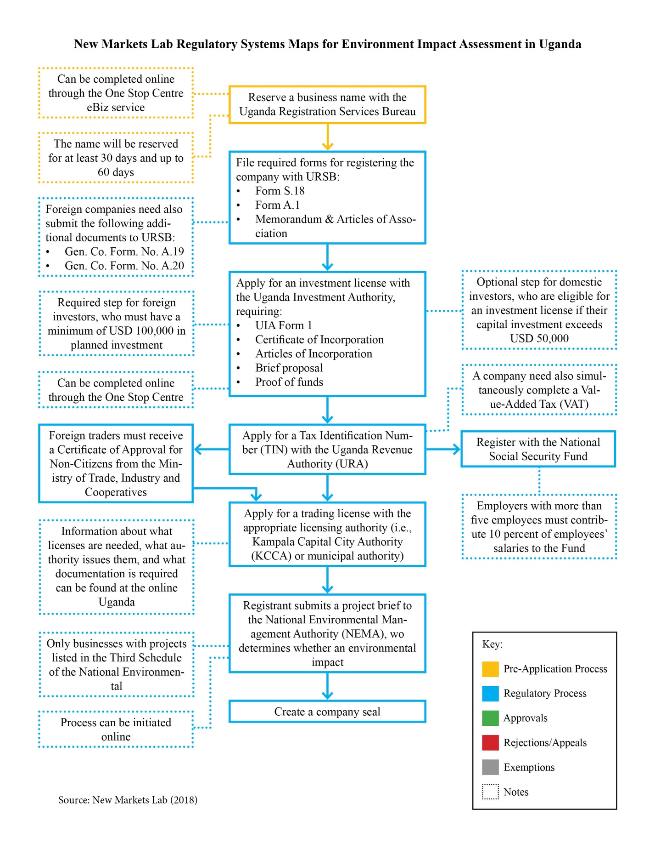

Doing Business 2018, Economy Profile – Ghana, World Bank Group, 2018.
Ghana Investment Promotion Centre, “Business Registration in One Day as Gov’t Launches Regulatory Reforms,” <http://www.gipcghana.com/press-and-media/523-business-registration-in-one-day-as-gov-t-launches-regulatory-reforms.html> (accessed August 6, 2018).
Doing Business 2018, Ghana.
Mary Agboli, Gender and Economic Growth Assessment for Ghana 2007, International Finance Corporation and the Ministry for Women and Children Affairs, Ghana, 35.
Doing Business 2018, Ghana.
Doing Business 2010, Ghana, The World Bank Group, 2010.
Ibid.
Ibid.
Mary Agboli, Gender and Economic Growth Assessment for Ghana 2007, International Finance Corporation and the Ministry for Women and Children Affairs, Ghana, 8.
Ghana Investment Promotion Centre, “Business Registration in One Day as Gov’t Launches Regulatory Reforms,” <http://www.gipcghana.com/press-and-media/523-business-registration-in-one-day-as-gov-t-launches-regulatory-reforms.html> (accessed August 6, 2018).
Ibid.
Doing Business 2018, Ghana.
Ibid.
Ibid.
Section 9 of the Companies Code, 1963.
Doing Business 2018, Ghana.
Ibid.
Ibid.
Ibid.
Ibid.
Ibid.
The World Bank in The Gambia Overview, World Bank Group (April 19, 2018), <http://www.worldbank.org/en/country/gambia/overview> (accessed August 6, 2018)
Ibid.
Ibid.
Ibid.
Pavithra Rao, Gambia’s Democracy Survives Political Turbulence, United Nations (May 2017), <http://www.un.org/africarenewal/magazine/may-july-2017/gambia%E2%80%99s-democracy-survives-political-turbulence> (accessed August 6, 2018).
Ibid.
See generally, Constitution of the Republic of Gambia.
The Gambia Overview.
Roger Nord et al., The Gambia Debt Sustainability Analysis, International Monetary Fund (June 13, 2017), <https://www.imf.org/external/pubs/ft/dsa/pdf/2017/dsacr17179.pdf> (accessed on August 6, 2018).
Ibid.
All USD conversations are approximate based on exchange rate as on August 6, 2018.
See generally, The National Environment Management Act of 1994.
Ibid.
Ibid.
See, EIA Guidelines of 1999.
Ibid.
Ibid.
“Kenya’s Economy Overview”, Kenya Business Guide, < https://kenyabusinessguide.org/kenyas-economy-overview-2/> (accessed August 6, 2018).
Doing Business 2018, Economy Profile – Kenya, World Bank Group, 2018.
Ibid.
“Kenya’s Economy Overview”, Kenya Business Guide, < https://kenyabusinessguide.org/kenyas-economy-overview-2/> (accessed August 6, 2018).
See generally, Vision 2020, < http://vision2030.go.ke> (accessed August 6, 2018).
See, Public Communication Department, “Reforms for Ease of Doing Business in Kenya,” Office of the Attorney General and Department of Justice (June 22, 2016) <http://www.statelaw.go.ke/reforms-for-ease-of-doing-business-in-kenya/> (accessed August 6, 2018); Otiato Guguyu, “New Entity Setup to Register Companies,” Daily Nation, <https://www.nation.co.ke/business/New-entity-set-up-to-register-companies/996-3005596-6og3sez/index.html.> (accessed August 6, 2018).
Section 4 of the Business Registration Act, 2015 (hereinafter referred to as “the Act”).
Section 3(3) of the Act.
Section 5(2) of the Act.
Section 7 of the Act.
Section 18(4) of the Act.
Among other things, it has provisions governing the company’s constitution, capacity, name, members, directors, company secretaries, resolutions and meetings, share capital, distribution of assets, debentures, takeovers, accounting records and financial statements, auditing, and dissolution.
eCitizen portal can be accessed at <http://ecitizen.go.ke> (accessed August 6, 2018).
eRegulations Kenya can be accessed at <https://kenya.eregulations.org/?l=en> (accessed August 6, 2018).
E-Registry can be accessed at <https://kenya.eregulations.org/?l=en> (accessed August 6, 2018).
Business Licensing Portal can be accessed at <http://www.businesslicense.or.ke/index.php/index/index/id/2> (accessed August 6, 2018).
“Registering a Business Name”, eRegulations Kenya, <https://kenya.eregulations.org/procedure/153/103?l=en> (accessed August 6, 2018).
“About PIN”, Kenya Revenue Authority, <http://www.kra.go.ke/index.php/domestic-taxes/income-tax/about-pin> (accessed August 6, 2018).
“Register a Limited Liability Partnership”, eRegulations Kenya, <https://kenya.eregulations.org/procedure/270/170/step/563?l=en> (accessed August 6, 2018).
“Starting a Local Company”, eRegulations Kenya, <https://kenya.eregulations.org/procedure/2/8?l=en> (accessed August 6, 2018).
The World Bank in Nigeria Overview, World Bank Group (December 12, 2017), <https://www.worldbank.org/en/country/nigeria/overview> (accessed August 6, 2018)
Doing Business 2018, Economy Profile – Nigeria, World Bank Group, 2018.
A Guide to Doing Business in Nigeria 2015, PricewaterhouseCoopers Limited (2015).
The World Factbook – Nigeria Background, Central Intelligence Agency, < https://www.cia.gov/library/publications/the-world-factbook/geos/ni.html> (accessed on August 6, 2018).
“Business Reforms in Nigeria”, The World Bank, < http://www.doingbusiness.org/reforms/overview/economy/nigeria> (accessed on August 6, 2018).
Constitution of Nigeria (1999), Section 4.
Ibid at Part I of Second Schedule.
Companies and Allied Matters Act 2004.
See generally, Corporate Affairs Commission, <http://new.cac.gov.ng/home> (accessed August 6, 2018); The Corporate Affairs Commission website, provides the information, forms and recourses for corporate incorporation.
The Companies Regulation 2012.
The Companies Regulation 2012 was drafted under Sections 16, 585 and 609 of the Companies and Allied Matters Act.
Company and Allied Matters Act, Sections 54, 56.
“Doing business in Nigeria - a guide for foreign investors”. Simmons & Simmons LLP (2014), < http://www.elexica.com/en/legal-topics/corporate-governance-and-compliance/doing-business-in-nigeria-a-guide-for-foreign-investors> (accessed on August 6, 2018).
Companies and Allied Matters Act, Sections 21, 655, 673.
Ozofu Olatunde Ogiemudia and Christine Sijuwade, “Doing business in Nigeria”, Practical Law (2018).
Companies and Allied Matters Act, Section 246.
Ibid, Section 22.
Online registration can be accessed at <https://services.cac.gov.ng/#>
See generally, Corporate Affairs Commission website available at <https://services.cac.gov.ng/#> (accessed on August 6, 2018).
“User Guide for Public Users”, Corporate Affairs Commission, <https://services.cac.gov.ng/assets/docs/crp-user-guide.pdf> (accessed on August 6, 2018).
The Companies Regulation 2012, Section 6.
Ibid, Schedule 3.
The Companies Regulation, Schedule 3.
User Guide for Public Users.
Ibid.
“Forms”, Corporate Affairs Commission website, <http://new.cac.gov.ng/home/introduction-of-new-form-cac1-1-in-place-of-cac-2-2-1-4-and-7/> (accessed on August 6, 2018).
“Introduction of New Form”, Corporate Affairs Commission, < http://new.cac.gov.ng/home/introduction-of-new-form-cac1-1-in-place-of-cac-2-2-1-4-and-7/> (accessed on August 6, 2018).
Doing Business 2018, Nigeria.
Ibid.
Ibid.
See Pre-Incorporation Help tab on the Corporate Affairs Commission website, available at <https://services.cac.gov.ng/#> (accessed on August 6, 2018).
User Guide for Public Users.
Doing Business 2018, Nigeria.
The Companies Regulation 2012, Section 9.
“Registration Steps”, Corporate Affairs Commission, <http://new.cac.gov.ng/home/registration-steps/> (accessed on August 6, 2018).
Ibid, Section 15.
User Guide for Public Users.
Doing Business 2018, Nigeria.
“Registration Steps”, Corporate Affairs Commission, <http://new.cac.gov.ng/home/registration-steps/> (accessed on August 6, 2018).
Companies and Allied Matters Act, Section 74.
Doing Business 2018, Economy Profile – Tanzania, World Bank Group, 2018.
Integrated Labor Force Survey 2014 – Analytical Report, United Republic of Tanzania - National Bureau of Statistics (November 2014).
Making the Law Work for Everyone – Volume 1, Commission on Legal Empowerment of the Poor, (2008).
National Five Year Development Plan 2016/17 – 2020/21, Ministry of Finance and Planning (June 2016), p. 110, < http://www.mof.go.tz/mofdocs/msemaji/Five%202016_17_2020_21.pdf> (accessed on August 19, 2018).
Property and Business Formalization Program – Experience in Formalization of Squatter Settlements, UNPSA Forum (June 2012), < http://unpan1.un.org/intradoc/groups/public/documents/un-dpadm/unpan049700.pdf> (accessed August 6, 2018).
National Five Year Plan, p. 82.
Doing Business 2018, Economy Profile – Tanzania, World Bank Group, 2018.
“Business Names”, Business Registration and Licensing Agency, <http://www.brela.go.tz/index.php/business/about> (accessed on August 6, 2018).
Ibid.
Doing Business 2018, Tanzania.
Ibid.
Ibid.
Ibid.
“Starting Business”, Tanzania Revenue Authority, <http://www.tra.go.tz/index.php/starting-business> (accessed on August 6, 2018).
Doing Business 2018, Tanzania.
“Obtaining a Business License”, Tanzania National Business Portal, <https://business.go.tz/obtain-a-business-license> (August 6, 2018).
Ibid.
Nicholas Zervos, et al., “Establishing a Business in Tanzania”, Practical Law (2018).
“The Workers Compensation Fund - How to Register and Contribute”, <http://sra.co.tz/the-workers-compensation-fund-how-to-register-and-contribute/> (accessed on August 6, 2018).
Doing Business 2018, Tanzania.
Ibid.
See generally, the Social Security (Regulatory Authority) Act, 2008.
Doing Business 2018, Tanzania.
“Social Security Program Throughout the World – Tanzania”, United States Social Security Administration, <https://www.ssa.gov/policy/docs/progdesc/ssptw/2016-2017/africa/tanzania.html> (accessed on August 6, 2018).
“Registering a Business in Rwanda”, Rwanda High Commission – New Delhi, India, < http://rwandahcdelhi.org/registering-a-business-in-rwanda/> (accessed August 6, 2018).
Doing Business 2018, Economy Profile – Rwanda, World Bank Group, 2018.
“Business Registration”, Rwanda eRegulations, < http://businessprocedures.rdb.rw/menu/1?l=en> (accessed August 6, 2018).
Rwanda eRegulations portal can be accessed at < http://org.rdb.rw/> (accessed on August 6, 2018).
“Registering a Business in Rwanda”, Rwanda High Commission – New Delhi, India, < http://rwandahcdelhi.org/registering-a-business-in-rwanda/> (accessed August 6, 2018).
“Register as an enterprise (individual trader) online”, Rwanda eRegulations, < http://businessprocedures.rdb.rw/procedure/6/step/13?l=en&includeSearch=true> (accessed August 6, 2018).
Ibid.
Law No. 07/2009 of 27/04/2009 Relating to Companies (April 27, 2009).
Law No. 7, Article 8.
Doing Business 2018, Economy Profile – Rwanda, World Bank Group, 2018.
Ibid.
Ministerial Order No. 002/13/10TC of 31/07/2013 on Modalities of use of a certified Electronic Billing Machine, Official Gazette No. 34 of 26/08/2013.
Doing Business 2018, Rwanda.
Ibid.
Ibid.
Organic Law No. 04/2005 of 08/04/2005 determining the Modalities of Protection, Conservation and Promotion of the Environment in Rwanda (May 1, 2005).
One Stop Centre Registration Portal can be accessed at < http://osc.rdb.rw/> (accessed on August 6, 2018).
“Environmental Impact Assessment (EIA)”, Rwanda eRegulations, < http://businessprocedures.rdb.rw/procedure/137/40?l=en> (accessed on August 6, 2018).
Ibid.
Ibid.
Ibid.
The Uganda Registration Services Bureau can be accessed at < https://ursb.go.ug>
Doing Business 2018, Economy Profile - Uganda, World Bank Group, 2018.
“About”, One Stop Centre, <https://www.ebiz.go.ug/about/> (accessed on August 6, 2018).
Ibid.
Ibid.
Companies Act, 2012, The Uganda Gazette No. 52 Volume CV (September 18, 2012), Section 4(2)(d).
Companies Act, Section 4(2)(a-c).
“Search for Business Name”, One Stop Centre, < https://www.ebiz.go.ug/procedure/search-for-business-name-local-2/> (accessed on August 6, 2018).
“Business Registration Fees”, Uganda Registration Services Bureau, < https://ursb.go.ug/business-registration-fees-2/> (accessed on August 6, 2018).
“Reserve a Business Name”, One Stop Centre, < https://www.ebiz.go.ug/procedure/reserve-business-name/> (accessed on August 6, 2018).
Companies Act, Section 36(1).
Business Names Registration Act, 1918 (October 15, 1918), Section 4(1)(1-6).
“Search for a Business Name”, One Stop Centre, <https://www.ebiz.go.ug/service/search-for-a-business-name-local/> (accessed on August 6, 2018).
Companies Act, Section 18(1).
“Business Registration Fees”, Uganda Registration Services Bureau, < https://ursb.go.ug/business-registration-fees-2/> (accessed on August 6, 2018).
Companies Act, Section 18(1) and Second Schedule.
“Obtain Certificate of Incorporation”, One Stop Centre, < https://www.ebiz.go.ug/procedure/obtain-certificate-of-incorporation-local/> (accessed on August 6, 2018).
Companies Act, Section 228(5) and 228(6).
“Register a Company”, One Stop Centre, <https://www.ebiz.go.ug/service/reserve-the-company-name/> (accessed on August 6, 2018).
“Obtain Certificate of Incorporation”, One Stop Centre, < https://www.ebiz.go.ug/procedure/obtain-certificate-of-incorporation-local/> (accessed on August 6, 2018).
“Business Registration Forms”, Uganda Registration Services Bureau, < https://ursb.go.ug/business-registration-forms/> (accessed on August 6, 2018).
Companies Act, Section 18(3).
Companies General Regulation 29(1).
Companies Act, Section 252(2)(a).
“Obtain Certificate of Incorporation”, One Stop Centre, <https://www.ebiz.go.ug/procedure/certificate-of-incorporation-foreign/?f=foreign> (accessed on August 6, 2018).
Ibid.
Ibid.
Ibid.
Companies Act, Section 252(1)(a-e).
Investment Code 10(1)
“Obtain an Investment License”, One Stop Centre, <https://www.ebiz.go.ug/procedure/obtain-an-investment-license/> (accessed on August 6, 2018). See also, Investment Code 6(g): the UIA may determine terms and conditions which can be imposed in relation to the operation of a business enterprise; and 18(2)(a): a license may require that the investor not invest less than a specified amount in relation to the value of machinery, buildings, or other assets.
“Obtain an Investment License”, One Stop Centre, <https://www.ebiz.go.ug/procedure/obtain-an-investment-license/> (accessed on August 6, 2018).
“Starting a Business”, Uganda Investment Authority, < http://www.ugandainvest.go.ug/why-uganda/starting-a-business/> (accessed on August 6, 2018).
Uganda Investment Authority - Check list of required documents for an Investment License, <http://www.ugandainvest.go.ug/wp-content/uploads/2016/02/Checklist-for-Investment-Licence.pdf> (accessed on August 6, 2018).
“Starting a Business”, Uganda Investment Authority, <http://www.ugandainvest.go.ug/why-uganda/starting-a-business/> (accessed on August 6, 2018).
“Investment License”, One Stop Centre, < https://www.ebiz.go.ug/service/investment-license/> (accessed on August 6, 2018).
See, e.g., Income Tax Act 2(sss): “‘taxpayer’ means any person who derives an amount subject to tax under this Act” and S. 4: “Subject to and in accordance with this Act, a tax to be known as income tax shall be charged for each year of income and is imposed on every person who has chargeable income for the year of income.”; See also, e.g., Value-Added Tax Act 5: Person liable to pay tax—“Except as otherwise provided in this Act, the tax payable—1. in the case of a taxable supply, is to be paid by the taxable person making the supply; 2. in the case of an import of goods, is to be paid by the importer; 3. in the case of an import of services, is to be paid by the recipient of the imported services.”
Tax Procedures Code Act, 2014, Section 4(1).
Tax Procedures Code Act, 2014, Section 5(1); Income Tax Act (Amendment), 2011, Section 12.
The Uganda Revenue Authority portal can be accessed at <https://www.ura.go.ug/#>
Value Added Tax Act 1996, Section 7(1)(2).
Application for VAT Registration, <https://www.ura.go.ug/download/forms/registration/DT-1011_VAT_Reg.pdf>
Ibid.
Trading (Licensing) Act, 1969, Section 8(1).
Trade (Licensing) Act, Section 8 (1-5).
Trade (Licensing) Act, Section 10(1).
Trade (Licensing) Act, Section 30(1-2).
“Revised Trading License Rates”, Kampala Capital City Authority, <https://www.kcca.go.ug/trading-licence-rates> (accessed on August 6, 2018).
“Revenue Services”, Kampala Capital City Authority, < https://ecitie2.kcca.go.ug/portal/.> (accessed on August 6, 2018).
“Trading License”, Kampala Capital City Authority, <https://www.kcca.go.ug/uDocs/Trade_Licence_FAQs.pdf> (accessed on August 6, 2018).
Ibid.
The Uganda Business Licensing Information Portal can be accessed at <http://www.businesslicences.go.ug/index.php>
“Press Release on Foreign Traders in petty Trade”, Ministry of Trade, Industry and Cooperative, <http://www.mtic.go.ug/index.php?option=com_content&view=article&id=122&Itemid=268> (accessed on August 6, 2018).
Ibid.
Ibid.
Investment Code Act, Section 10(5)(b): “A foreign investor who is intending to engage in trade only shall not be required to comply with subsection (1) but shall…deposit a sum of one hundred thousand United States dollars or its equivalent in Uganda shillings at the Bank of Uganda…” and 10(6): “Upon compliance with subsection (5), the Bank of Uganda shall issue a certificate of remittance to the foreign investor.”
See “Application Form for Certificate of Approval to Conduct Trading in Uganda by Non-Citizens”, Ministry of Trade, Industry and Cooperative, < http://www.mtic.go.ug/index.php?option=com_content&view=article&id=122&Itemid=268> (accessed on August 6, 2018).
National Environment Act, 1995, Section 19(3).
National Environment Act, Third Schedule.
National Environment Act, Section 19(1).
EIA Regulations, Part II 5(1)(a-i).
“Environmental Impact Assessment Certificate”, One Stop Centre, <https://www.ebiz.go.ug/service/environment-impact-assessment/> (accessed on August 6, 2018).
Environmental Impact Assessment Regulations, 1998, Section 9(2).
National Environment Act, Section 19(5)(a-c).
National Environment Act, Section 20(1).
EIA Regulations, Section 14(1)(a-m) and 15.
EIA Regulations, Section 25(1)(a-d).
“Environmental Impact Assessment Certificate”, One Stop Centre, <https://www.ebiz.go.ug/service/environment-impact-assessment/> (accessed on August 6, 2018).
Where the total value of the project exceeds UGX 5,000,000,000, then the amount payable is 0.1 percent of the total value of the project. EIA Regulations, Schedule Three.
“Register with National Security Fund”, One Stop Centre, <https://www.ebiz.go.ug/procedure/register-with-national-social-security-fund/?f=foreign> (accessed on August 6, 2018).
Employer Registration Form – National Social Security Fund, <https://www.nssfug.org/uploads/registration1.pdf> (accessed on August 6, 2018).
“Frequently Asked Questions”, National Social Security Fund, <https://www.nssfug.org/135/FAQs#faq3> (accessed on August 6, 2018).
“Contributions”, National Social Security Fund, <https://www.nssfug.org/12/Contributions/> (accessed on August 6, 2018).
Companies Act, Section 117(b); “Making a Company Seal”, One Stop Centre, <https://www.ebiz.go.ug/procedure/make-company-seal/> (accessed on August 6, 2018).

